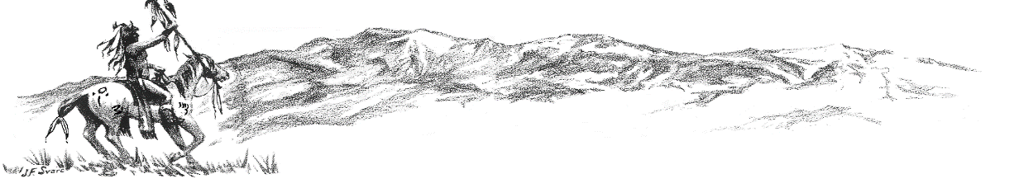

Colorado City Happenings June 2023

**Employee Spotlight**

Greg Bailey has been working for CCMD since April 1, 1988. With a chuckle he says, “The joke’s on me!” He started as an assistant at the golf pro shop, moved to golf course maintenance, on to the water and sewer dept, back to the golf course, and with developed knowledge and experience finally to the water and sewer enterprises to work on collection and distribution. When I caught up with Greg, he was tying up a few loose ends of a very long breakdown plagued shift. Asked what he liked most about his job, he responded “every day is a new (unique) day”. He stated, “I really enjoy the people I work with and the many friends I have made”. With a smile his comment about what he disliked referred to working 23 hours straight. In closing our visit, he pleasantly commented “it’s been a good career” and gave credit to Jim (District Mgr) and the board for making great strides in pushing forward projects that he could be proud of for the benefit of Colorado City. Greg, his wife, and “grown and gone” kids, have called Colorado City home for 30+ years.

**Election of New CCMD Board**

Welcome to our 2 new Board members, Ray Davis and Clint Gross and incumbent Neil Elliot. The May election received good turnout and was expectedly close amongst 5 quality candidates. Both Ray and Clint are quickly getting up to speed on ongoing projects and being active in CCMD issues. We will continue to have an active board and welcome citizen input to all board members.

And… a sincere Thank you to Harry Hochstetler and Terry Kraus for your past service (and future help).

**Water Tank Repair Project**

The project to repair / refurbish water storage tanks 1, 2, and 3 is in the early stages and will become more visible soon. One at a time each tank will be drained for the repair / refurbish work to be done. We are currently working with old valves and lines to be able to isolate a tank and still provide water to residents.

Even though we have received a good amount of moisture from Mother Nature, we are still on water restriction Level Two because of the need to drain each storage tank to continue the project. Please help us maintain adequate water supply by continuing to conserve.

**Kudos / Upgrades / Improvements**

Kudos to the Rye-Colorado City Saddle Club! The new signs look great. And a further look reveals an active, nicely maintained and attractive facility. Good Job!

Thanks to the CCMD office staff for cleaning up around the front of our main office with the help of the Parks and Recs Department. It looks great and shows pride!

The Greenhorn Meadows Campground is receiving upgrades to the gazebo, some campsites, and facilities. Welcome your friends and family for a visit and a neat place to camp while here.

Thanks to VFC and Greenhorn Valley Chamber of Commerce for highway cleanup. More pride in our community.

Kudos to Valley First for a great job of gathering funds and interest to rehab, improve, and expand sports facilities in Greenhorn Meadows Park.

Save the date for Greenhorn Valley Days July 29th promoted by Valley First.

And…Kudos to Mother Nature for our green grass!! The Greenhorn Valley looks beautiful!

**Colorado City Architectural Control Committee**

A reminder! Colorado City is controlled by Covenants. Please check the covenants before construction or placement of accessory buildings (sheds, storage containers, etc.) Most units have specific requirements for such. The Covenants are on the CCMD website or available by calling the CCMD office.

**Easy to Pay by Drop-Box, Phone or Internet**

Your water bill can be easily paid 24/7 at the secure drop-box located on the North side of the CCMD office building, or by phone, or internet (coloradocitymd.colorado.gov). Instructions are on the bill and help is available by phoning the office.

**Town Hall Chat**

The CCMD Board would like to hear from you. Our next informal town hall chat will be August 15th at 6 pm. Please come ask questions and give comments or just visit.

Also… the drop box on the north side of the CCMD office building is available for dropping off comments, questions, payments, etc.