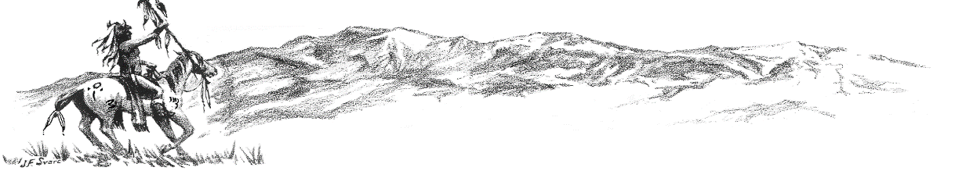

Colorado City Happenings

September 2023

**Employee Spotlight**

Josh Briggs was on his way out the door to install some soccer goals for youth soccer when I caught him for “just a couple minutes”. Josh, a Rye High School alum, started working for CCMD in 2015 as a utility worker and stepped up to the job of Director of Parks and Rec in 2018. Just a short visit reveals the passion he has for youth activities so it’s no surprise when he says the best part of his job is “working with the kids”. Josh is responsible for managing, maintaining, and improving all of CCMD parks and recreation facilities on a limited budget and staff, as well as organizing and scheduling sports activities and associated personnel. He commented with relief that with the help of his new part-time employee, Tiffany Weston, he had just recently finally found enough coaches to work with the 94 kids signed up for youth soccer (up from 66 kids last year). So, when you notice a new playground as in Applewood, freshly mowed greenbelt, attractive ball fields, neat park and campground, etc., etc., tell Josh thanks.

Vandalism, trash, unauthorized vehicle traffic on greenbelts, and abuse of amenities are major frustrations for Josh (and all of us). We can eliminate that frustration by simply being a responsible citizen and expecting others to be the same. Let’s do it!

**Lake Beckwith Dam**

CCMD signed the contract for RJH Engineering to begin the engineering for the rehabilitation of Lake Beckwith Dam. The dam is over 100 years old and although it has shown no movement it needs to be rehabilitated and stabilized for the future. We are including in the dam engineering a footprint for the much anticipated DAF pretreatment system. The next step is procuring the funding for construction. Because of an improved financial condition, we are in an optimistic position to acquire grants and loans with attractive terms. With Colorado State approval construction should begin late 2024.

**Water!**

The cooler temperatures have helped! The water dept crew doesn’t like the funky water either. And they are busting their tails to provide adequate quality water. With the new types of algae and an abnormally hot summer this was quite a challenge. Again…plant upgrades can’t come soon enough!

**Recycling**

The recycling program offered by CCMD has become a problem. The holding area for the service provided by Roots Recycling from Pueblo has become a dumping ground for trash, unaccepted items, and unaccepted bags/containers. Before Roots’ scheduled pickup, Josh (Parks and Rec) must sort through the mess and haul the unaccepted items/trash to landfill.

Also, Roots Recycling has found it necessary to raise their service fees and accepted bag costs. For us to continue to provide a recycling service we will need to approximately triple the cost of the bags Roots requires to be used.

Considering the unacceptable mess created for Josh and the increased costs, the inclination is to discontinue the recycling program. Recycling is still available by delivering to a Pueblo recycling center, but CCMD would not provide the service connection. We would appreciate input, comments, suggestions about the wisdom of CCMD continuing or discontinuing the recycling program.

**Colorado City Architectural Control Committee**

A reminder! Colorado City is controlled by Covenants and Pueblo County is controlled by Land Use Regulations and Codes. Please check the Covenants and Land Use Regulations and get approval before construction or placement of accessory buildings (sheds, storage containers, etc.) Most units have specific requirements for such. The Covenants are on the CCMD website or available by calling the CCMD office.

**Easy to Pay by Drop-Box, Phone, or Internet**

Your water bill can be easily paid 24/7 at the secure drop-box located on the North side of the CCMD office building, or by phone, or internet. Instructions are on the bill and help is available by phoning the office. Also… the drop box on the north side of the CCMD office building is available for dropping off comments, questions, payments, etc.

**Town Hall Chat**

The CCMD Board would like to hear from you. Our next informal town hall chat will be October 17, 2023, at 6 pm. Please come ask questions and give comments or just visit.